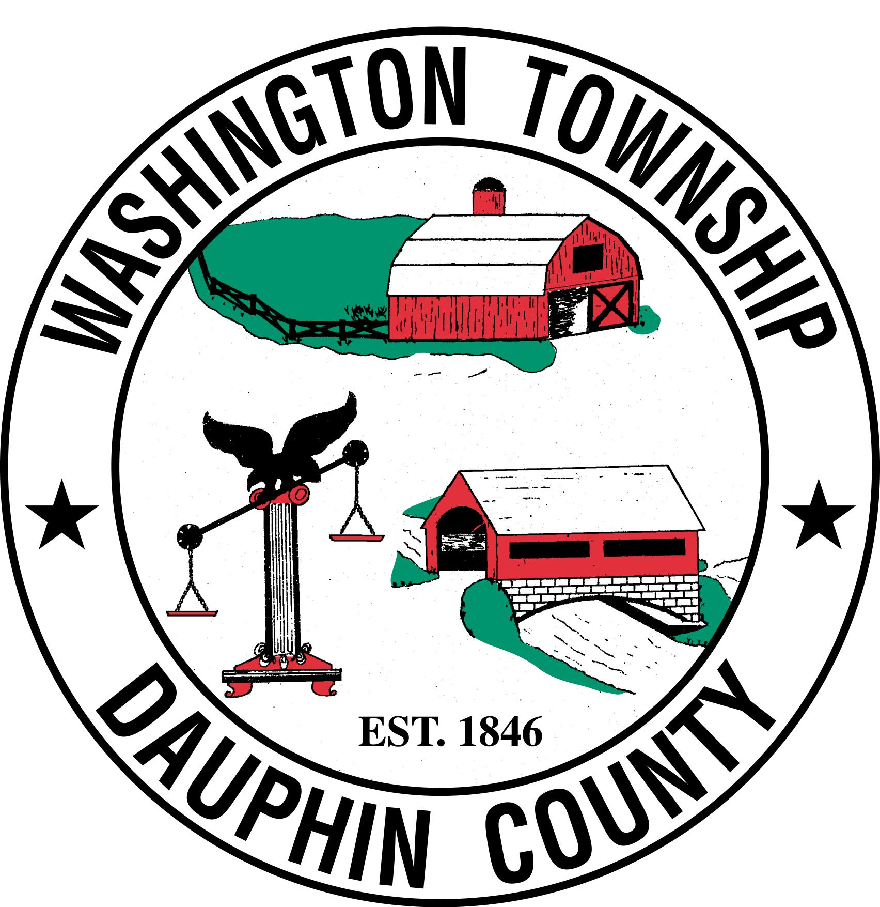

WASHINGTON TOWNSHIP PLANNING COMMISSION
Washington Township Municipal Building
185 Manors Road
Elizabethville, PA 17023

December 2, 2024

I. Call Meeting to Order

II. Public Comments

III. Minutes of November 11, 2024

IV. New Business
- Establish 2025 Meeting Dates

V. Old Business

VI. Adjournment

